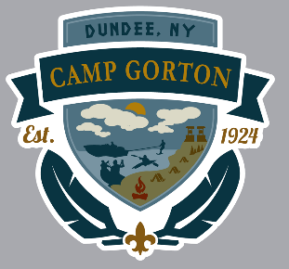
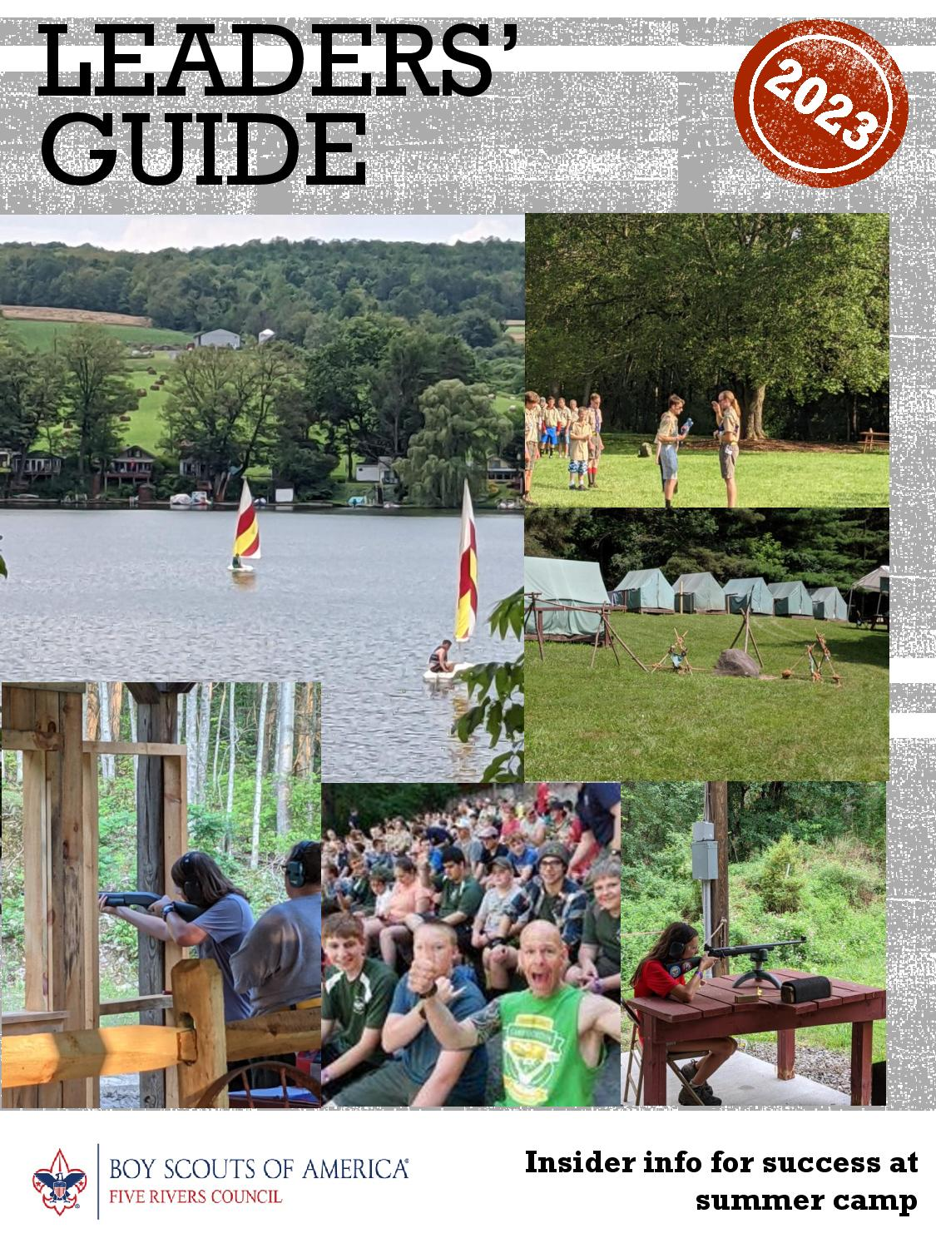 Camp Planning in 4 Easy Steps
Step 1: Read this Guide entirely. Each year there are program and procedural changes. This guide provides all the latest information.
Step 2: Get Organized. Start the planning process with your unit now so you can get the information you need in advance of deadlines.
Step 3: Ask questions. If you are unsure of anything, please don’t hesitate to reach out. Parents’ questions should be directed to Unit Leaders to streamline communications with Council.
• Camp Director E-mail- campgortondirector@gmail.com
• Telephone - (607) 732-9047 (Council Office).
From June 25th to Aug. 4th, call (607) 292-3220 (Camp Gorton Office)
.
Step 4: Help us help you. Some things will go wrong. That’s life. Please let us know ASAP so we can work with you to address any issues that crop up.
Checklist
- ASAP Site reserved
- Early Winter Troop meeting planned to promote Summer Camp
- Mid-Winter Troop leaders who will be attending Camp identified
- Camperships due March 15th
- February start entering contact info and birthdays for all Scouts & leaders into reservation system
- Before May 1st start registering and paying online to take advantage of early registration discounts
- April Troop meeting planned for Scouts to select Merit Badges
- June 1st final payments paid to avoid late fee
- May 15th online merit badge and activity registration starts for Scouts that registered
- June final plans including departure time and Scout schedules distributed to Unit
- At least 2 weeks prior:
  - Forms submitted to Five Rivers Council. Forms can be downloaded from our website at http://fiveriversbsa.org/camping/scouts-bsa-resident-camp/. PLEASE make certain parents sign all Scout forms.
  - BSA medical form, parts A & B & C for ALL participants staying over 24 hours
  - Special needs accommodation form email
  - Food allergies & dietary needs form
- 1 week prior:
- Thursday prior All Troop activities and individual advancements loaded and double checked

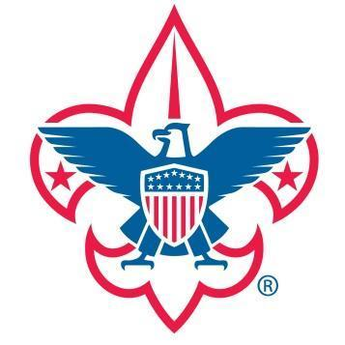
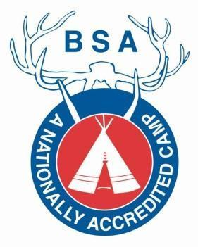

Important Dates

Scouts BSA Resident Camp

Session 1: 7/2 – 7/8
Session 2: 7/9 – 7/15
Session 3: 7/16 – 7/22

Campership
Application Due
3/15/2023

Early Bird
Registration Due
05/01/2023

Pre-Camp
Leader’s Meeting
06/28/2023

Camp Fees

Early Bird Fee–May 1, 2023
$525.00

Regular Fee – May 2, 2023
$550.00

Late Fee–After June 1, 2023
$600.00

Additional Week of Camp
$475.00

3 Weeks of Camp!
$1500

Leader’s Fee
$180.00

Mission Statement
The mission of the Boy Scouts of America is to prepare young people to make ethical choices over their lifetimes by instilling in them the values of the Scout Oath and Law.
Unit Deposit
$100.00

Scout Oath

On my honor, I will do my best to do my duty to God and my country and to obey the Scout Law; to help other people at all times; to keep myself physically strong, mentally awake, and morally straight.
Scout Law
A Scout is trustworthy, loyal, helpful, friendly, courteous, kind, obedient, cheerful, thrifty, brave, clean, and reverent.
Contact Information

Camp Gorton
4241 County Route 25
Dundee, NY 14837
(607) 292-3220

http://fiveriversbsa.org/

Ian Walruth
Camp Director
campgortondirector@gmail.com

Joe Fountain
Camp Ranger
joseph.fountain@scouting.org

Visitor Meals
Breakfast - $6
Lunch - $8
Dinner - $11

CONNECT WITH
SOCIAL MEDIA
/campgorton
Camp Gorton
@campgorton
CAMP GORTON’S
Like and follow us to make sure you get program updates, camp info, and pictures as soon as they are posted!

About Camp Gorton

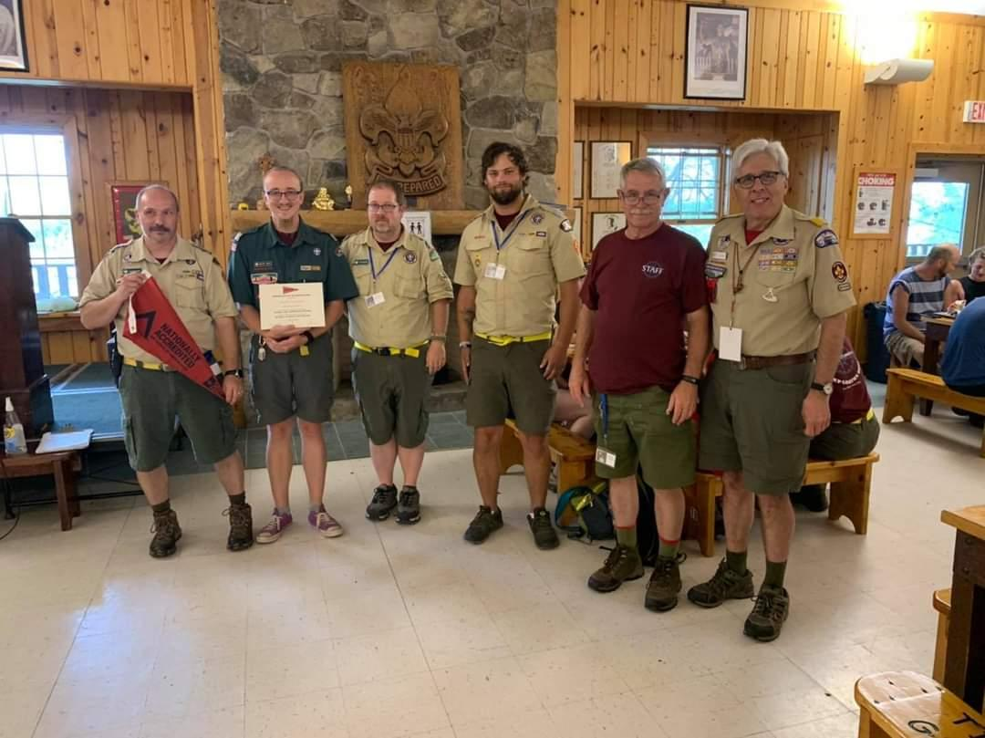
Camp Gorton is licensed to operate as a youth camp by the State of New York, the New York Health Department, and the National Council of the Boy Scouts of America. An accredited camp, Camp Gorton is inspected annually, meeting or exceeding strict quality standards which include, a long-range plan, staff qualifications/training, and health and safety requirements. Every Scouts BSA camp must operate under BSA National Camping Standards, along with State and Federal regulations. The agency that has the stricter standards is the set of standards that we meet. All questions regarding summer camp procedures & policies should be directed to the Five Rivers Council office at (607) 732-9047. Copies of the most recent New York Health Department or National BSA inspections are available upon request by contacting the Five Rivers Council office.

While attending Camp Gorton you will find a camping program designed to meet the needs of every Cub Scout, Scouts BSA, and Adult Scouter. During the Scouts BSA Summer Camp Program, the first-year camper (called F.Y.R.E.) is offered and for the more experienced Scouts there are programs designed to learn new skills/challenges. Camp Gorton provides a shower facility, a fully equipped dining hall, a First Aid building staffed 24 hours a day by certified medical personnel, supervised boating and swimming, a shooting sports program with .22 rifle, archery, and shotgun ranges, an ecology program, craft lodge, scoutcraft area, STEM lab, the trading post, and much more.

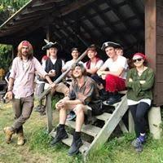
Camp Gorton provides each unit with a campsite, which contains two-person tents on wooden platforms with cots and mattresses, bulletin board, flagpole, campfire area, washstand, and a latrine. Each camp site includes a canopy with picnic tables for working on projects or just hanging out and having fun. Adult leaders who are looking to explore camp, meet the staff, demonstrate scout spirit, and volunteer to help out should check out our Scoutmaster Merit Badge. By completing a small checklist provided by the Program Director, Scoutmasters and Adult Leaders have the opportunity to participate in their own program and earn this coveted patch! Returning Adult leaders should keep an eye open for another level of Scoutmaster Merit Badge as well! Information will be distributed at the Sunday Leaders’ Meeting.

Additionally, Camp Gorton offers a wide variety of camping opportunities to units during the off-season. These include camporees, winter camping, as well as weekend opportunities for individual units. More information is available on the council website including the ability to register on-line.

Registration Information

2023 Summer Camp Deposit & Fees

Reservations for the 2023 season require a $100 deposit. The form and deposit must be received and receipted to hold a reservation. Units can make specific campsite requests, but final placement is at the discretion of camp management. If a reservation for a campsite is made without a deposit, it will be held tentatively for 2 weeks. After that time is up and no deposit made, the unit will then be notified and removed from that campsite. Since site deposits are applied to each year’s camp fees, a new deposit is required to reserve a week every year. Reservations can be made through the Five Rivers Council office at (607) 732-9047.
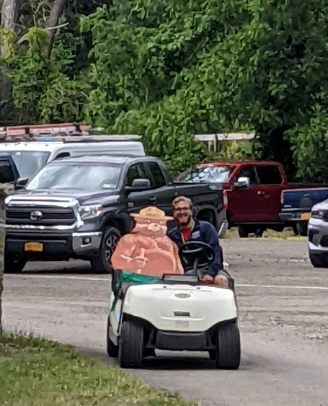
2023 Summer Camp & Payment Schedule

The 2023 Scouts BSA Camp fees are
$525.00 – paid in full by May 1, 2023
$550.00 – paid in full by June 1, 2023
$600.00 – paid after June 1, 2023

New Scouts

Webelos/Arrow of Light and other new Scouts who join a Scouts BSA unit during the spring will qualify for the discounted fee up to June 1, 2023. Five Rivers Council office must be contacted to have the discount applied.

Leader Fees

The Leader Fee is $180.00 per Adult per week. If a leader is not attending for the entire week of camp, but sharing leadership on a day-to-day basis, each will be charged $35.00 per 24-hour period. If a unit has a parent or leader visiting camp for less than 24 hours, they can pay for their meals at the camp Trading Post.

Campsite Assignment Policies

It is our responsibility to provide the opportunity for as many Scouts as possible to come to camp. This means that there are times that we must place two (or more) units into one campsite to utilize space and leadership. This serves the interests of all Scouts and allows for greater opportunities for more campers.
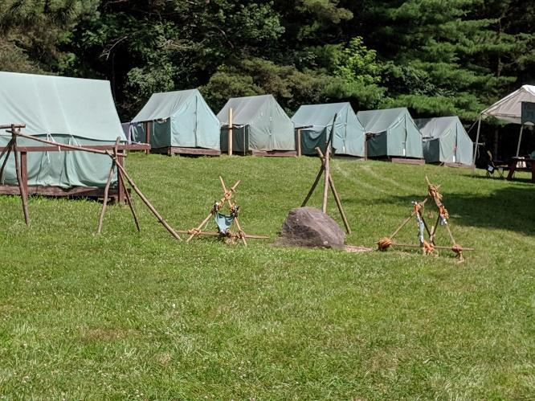
Units that do not fill at least 80 percent of the rated campsite capacity may have another unit assigned to share their campsite. Your cooperation and understanding is greatly appreciated.

CAMP GORTON CAMPSITE CAPACITIES
Lakeside Campsites
Algonquin | 30
Don Cobb | 30
Mohawk | 30
Iroquois A | 40
Iroquois B | 20
Hillside Campsites
Onondaga | 40
Blackfoot | 30
Oneida | 26
Cherokee | 28
Andaste | 24
Cayuga | 32

Camp Gorton Site Listing and Maximum Capacity

**A camper is defined as either a Scout or adult leader. Per New York State requirements, campsite capacity cannot be exceeded to accommodate more than what is listed. Overflow units in two sites must make arrangements for at least two additional leaders to attend camp. Extra tents cannot be made available to exceed site capacity without pre-approval.

Required Unit Leadership
Units must maintain the minimum two-deep leadership at all times and all leaders MUST be YPT certified. Each unit must have at least two adult leaders age 21 or over. All Scouts BSA troops for girls must have at least one female adult leader over 21. All leaders staying over 72 cumulative hours must be BSA registered and must be Youth Protection Trained. The BSA requires that at all leaders coming to camp successfully complete Youth Protection Training before attending summer camp. Anyone staying in camp for more than 24 hours must provide a medical form to the Camp Medical Officer. Please note that adult leaders may not bring children other than their paid Scout to camp.

Baden Powell Scouts – Scouts not attending camp with Unit
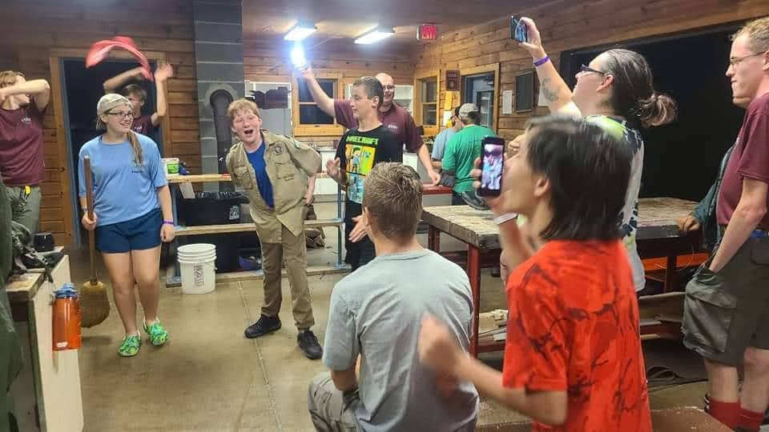
Scouts can attend Camp Gorton without their home unit and be part of the Baden Powell Scout program and function as a Troop for the week under the direction of the Baden Powell (provisional) Scoutmaster in camp. If Baden Powell (provisional) campers are too low to form a Troop, scouts will be added to another Troop in camp for the duration of their time in camp.
Scouts may choose to come back for additional weeks before or after their Troop has already attended camp. Any Scout may attend an additional week at Camp Gorton for a reduced fee of $475.00. Scouts wishing to attend Baden Powell (provisional) camping experience should pay their fees individually through the council office or online. Baden Powell (provisional) Scouts pay the same fees under the same timeline as Scouts attending camp with their Troop.

Camperships
Any Five Rivers Council unit with Scouts in need of financial assistance in order to attend summer camp may apply for a Five Rivers Council Campership. The Campership application form can be found on the Five Rivers Council website. Be advised, Camperships are not automatic. Scouts in need will typically receive 10%-50% of the Early Bird fee from the Council Campership Fund. Campership funding is partially dependent on Friends of Scouting and other fundraising successes. Individual accounts for each Scout should already be set up in your unit. The 9th point of the Scout Law is “A Scout is Thrifty”. Scouts are expected to earn some of their summer camp fees by participating in fundraising activities of the unit, as well as family and unit support.

Return the completed Campership Application to the Five Rivers Council office no later than March 15, 2023. Campership requests will not be accepted after this date. Notification of a Campership award will be sent to the parents and unit leader before April 1, 2023 with additional instructions.
Refund Policy

Requests for a refund received after June 1st will be subject to a cancellation fee. Refund requests after the week of camp will not be accepted. To minimize the need for refunds, camp fee transfers are highly recommended and encouraged from within the unit. Each unit is responsible for the tracking and processing of fees paid and to which Scout they are associated.

The Scouts BSA Summer Camp Cancellation Fee is $275.00 per Scout.

Pre-Camp Informational Meeting for Leaders

Available for adult leaders and Troop Senior Patrol Leaders, this meeting will provide you with all the information your unit needs for final camp planning. Key Staff members will be on hand to answer your questions, and each unit should arrange to send at least one representative to the pre-camp meeting.

The pre-camp Leaders’ Meeting will be
Wednesday, June 28, 2023 at 7:00 PM
in the Memorial Lodge at Sunny Camp Gorton.

You’re invited to attend the evening meal at 6:00 PM before the meeting. Meal tickets are available at the Trading Post. Please RSVP to the Camp Director whether or not your unit plans to attend. The Leader’s Meeting starts promptly at 7:00 PM. Please bring with you a complete roster of Scouts and adult leaders attending camp, a list of Scouts and leaders with special medical or dietary needs and list of any questions or concerns you might have.

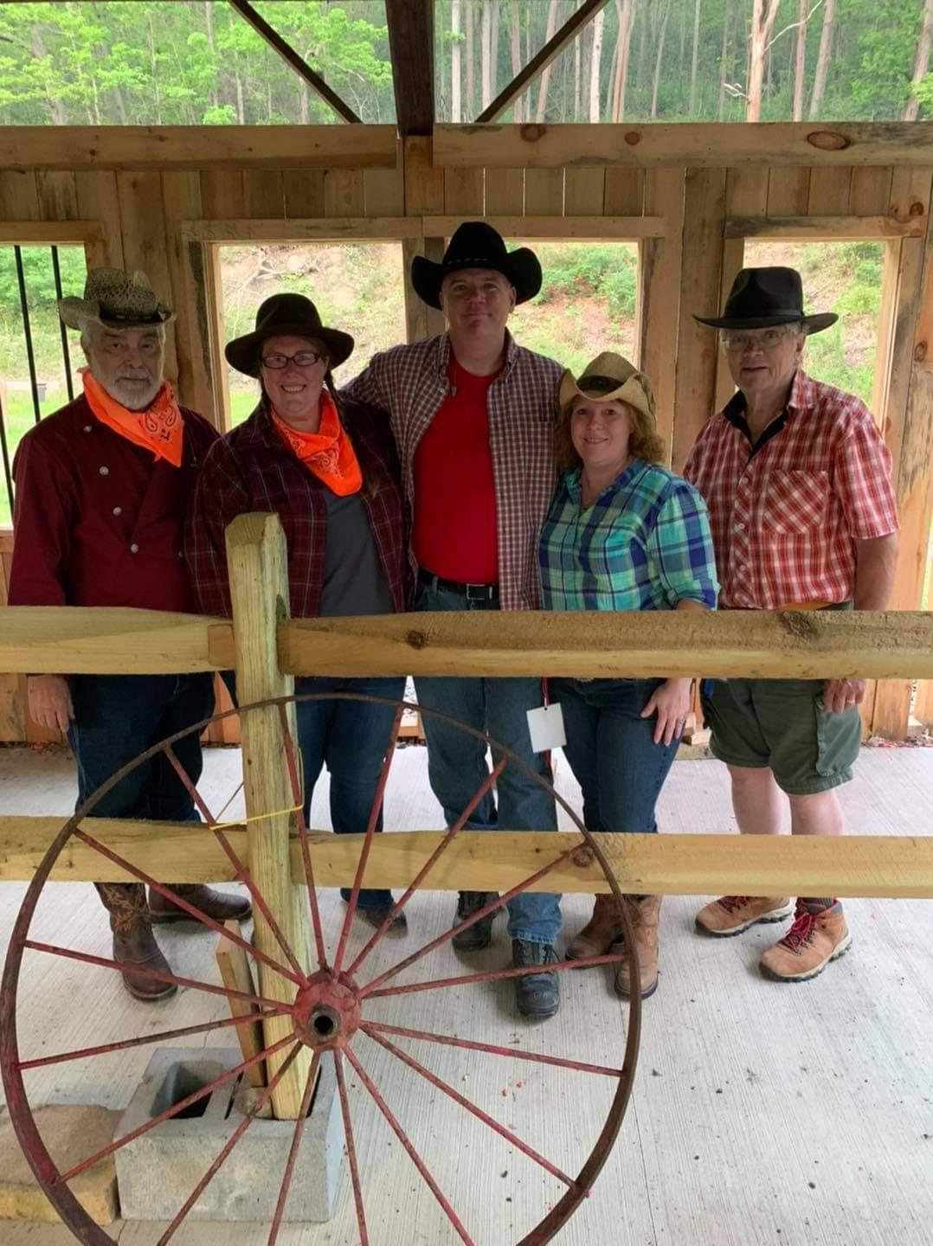
Online Merit Badge Registration
We offer online merit badge pre-registration for selection of merit badges for your Scouts at Camp Gorton. Your Troop’s primary summer camp leader will receive an email with your Troop’s necessary materials to pre-register each Scout attending camp on the website in April. On or before May 1st, we ask each unit to enter all your Scouts names into the website to ensure MB registration goes smoothly. The merit badge registration will go live on May 15, at 6:00 PM, Eastern Standard Time. It is recommended that each youth review the merit badge schedule with your Scoutmaster and setup their preferred schedule, and then one person within the unit enter their selections. New youth may be entered or changes may be made online now to help with merit badge registration in May.
Health & Safety

General Safety
Please review the current “Guide to Safe Scouting” prior to coming to camp.

First Aid Building
First aid services are available 24 hours a day by certified medical personnel during the summer camp season.

Health Forms
It is BSA and NYSDOH policy that everyone, youth or adult, who stays overnight at Camp provide a completed Annual Health and Medical Form. Those staying overnight in a Children’s Camp in New York State, but less than 24 consecutive hours, must provide Parts A and B completed and signed. Anyone spending more than 24 consecutive hours in camp must also provide a completed Medical Form including Part C signed by a Physician (As defined on the current Medical form) dated within the last year of the date of the end of your session of camp. A family physicians form may be attached to the BSA Form but does not replace the information needed from the BSA form. All information on the form must be provided.

Special Needs, Allergies and Dietary Restrictions

Scouts or adults who have special needs due to a physical or mental disability, or special diets due to medical or religious requirements will be accommodated to the best of our ability. Special needs not specified on-line need to be addressed to the Five Rivers Council office or the Camp Director. The sooner this information is available, the better your needs can be met. Please provide special food needs at least one week prior to camp.

Medical Procedures

A certified medical officer is available 24 hours a day. Any injuries or illnesses occurring at camp, no matter how minor, must be reported to the health lodge to be logged. In the event of a medical emergency, the health lodge and medical officer can be contacted at any time. Radio contact is available from all program areas, the dining hall, trading post, and camp office.
The health lodge is prepared to handle all illness and injury, with a licensed medical doctor under agreement and on call. Adult leadership should be aware of Scouts medical needs and observant of their activities, realizing that camp activities may affect Scouts differently than routine home life. All injuries, including those treated by the unit leadership, must be reported to the Health Officer and logged. In the event of serious injuries or illnesses, do not move the victim. If you are trained in first aid, begin treatment and have someone contact the nearest staff member, they are trained to handle the situation.

Arriving at or Leaving Camp
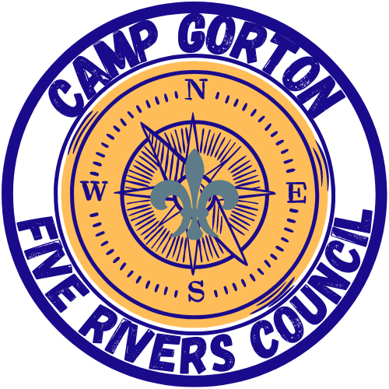
Your Arrival at Camp

Check in will be between 1:00 – 2:00 PM for Scouts BSA Summer Camp.

Units will not be checked in early!

Camp Tour

A camp tour is part of the camp check-in process and will help serve to answer questions, note changes, and help orient new campers and leaders. Even if you have attended camp here before, we ask that you go on the tour, as new Scouts will be unfamiliar with camp and there are always new activities at Camp to learn about.
Anytime during the stay, if a unit has questions or issues, please talk to the Camp Director, the Program Director, or the Camp Commissioner.

4:00 PM Leader’s Meeting

At least one adult leader from each campsite is asked to attend a Leader’s Meeting in the Memorial Lodge (by the Waterfront Area). If your unit only has 2 adult leaders, the camp will provide adult leadership to ensure each unit’s participation. At this meeting, key staff personnel (Camp Director, Program Director, Camp Ranger, Commissioner, and Health Officer) will provide important information to ensure a safe and fun summer camp experience.
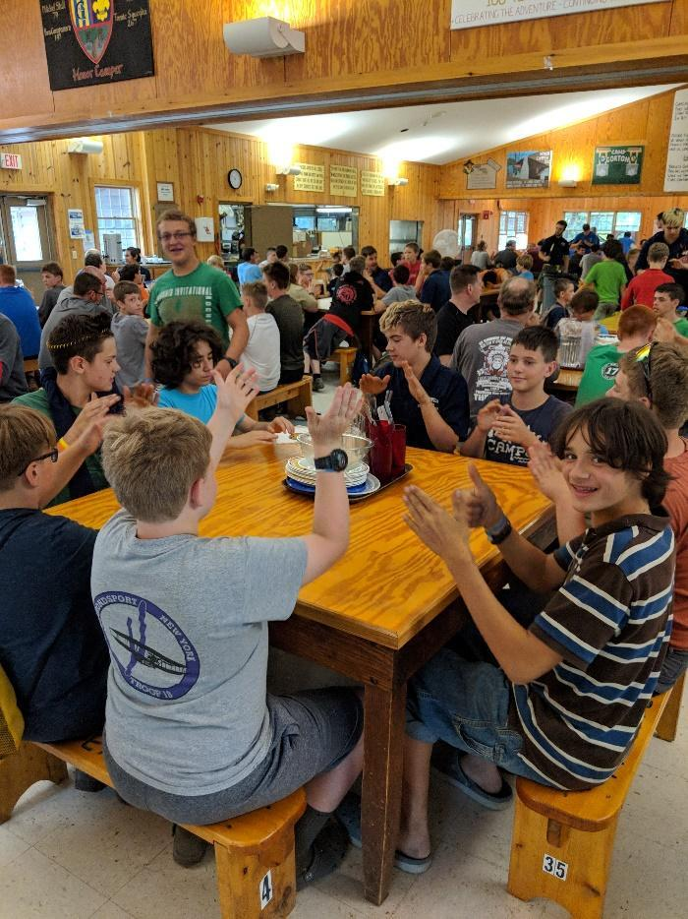
Dining Hall Procedures

Camp Gorton uses the family style of distributing and eating food. This consists of tables of eight where the “waiter system” is used in preparation of each meal, to deliver food to table during the meal, and clean up after the meal.

Meal Times - are: Breakfast: 8:00 AM Lunch: 12:00 PM Dinner: 6:00 PM

Special Meals - Requests for special meals to meet medically necessary dietary or religious needs must be requested prior to arrival at camp. This can be done in the online registration when asked about dietary restrictions, allergies, and medical concerns.

Visitors in Camp

Visitors are always welcome at camp; however, unit leaders and parents must coordinate their visits to camp, prior to arrival. Anytime a visitor, leader, or camper, enters or leaves camp, they MUST sign in or out at the Camp Office, 24 hours a day. Visitors must wear a Visitors Badge while on camp property. Visitor meal charges are per person and must be pre-paid in the Trading Post.

Transportation and Parking

Transportation to and from camp is the responsibility of each Scout’s parent and should be coordinated through the unit. Please review the “Guide to Safe Scouting” for transportation requirements.

The Buddy System
Scouts should never travel alone in camp! It is every unit leader’s responsibility to ensure that everyone in your unit is using the buddy system at all times. Scouts may pair up with other Scouts not in their unit. A Scout is friendly!

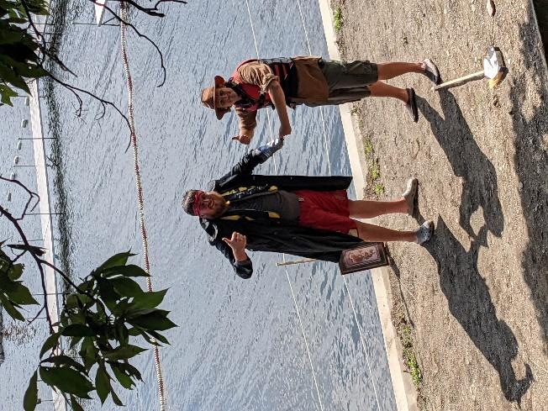

Camp Gorton Staff
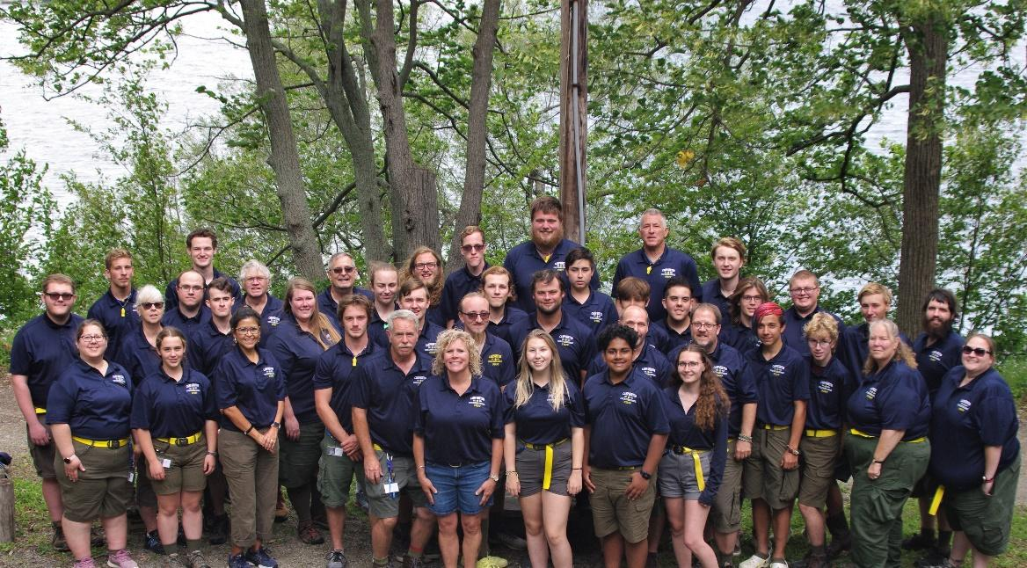
Camp Gorton takes exceptional pride in the quality of its camp staff. We hire exceptional teachers, leaders, and Scouters to provide the best summer camp experience possible. We employ roughly 50 Scouts and Scouters of all ages. They work tirelessly throughout the year to assemble an exceptional program for each summer. Many of the senior staff (18+) attend training at the Boy Scouts of America’s National Camping School in order to further expand the camp program. Collectively our staff completes hundreds of hours of training in program and camp safety. We promise that our staff will make every effort to ensure that your week is phenomenal and memorable.

Anyone interested in applying to work at Sunny Camp Gorton for the 2023 season should fill out the staff application online at: https://fiveriversbsa.org/wp-content/uploads/2022/08/Camp-Gorton-Staff-Application.pdf. Scouting experience is recommended, but not required.

Counselors-in-Training (CITs)

Each summer, our Counselor-in-Training (CIT) program prepares young scouts to become the next generation of camp staff. CITs are Scouts interested in becoming staff members at Camp Gorton that are 15 years old. Each CIT participates in delivering the program with the staff and attends Summer Camp with their unit. They will rotate between each program area and begin to get a sense of what it takes to become a staff member.

CITs do not need to be available for each week of program, but are expected to participate in staff week, our Cub Scout session, at least 1 Scouts BSA sessions, and taking down camp at the end of the summer. The CITs schedule can be discussed with the Camp Director and Program Director at the time of their interview.

Those interested in becoming a Counselor-in-Training should fill out the staff application online at: https://fiveriversbsa.org/wp-content/uploads/2022/08/Camp-Gorton-Staff-Application.pdf. CITs will be interviewed, as would any potential staff member.

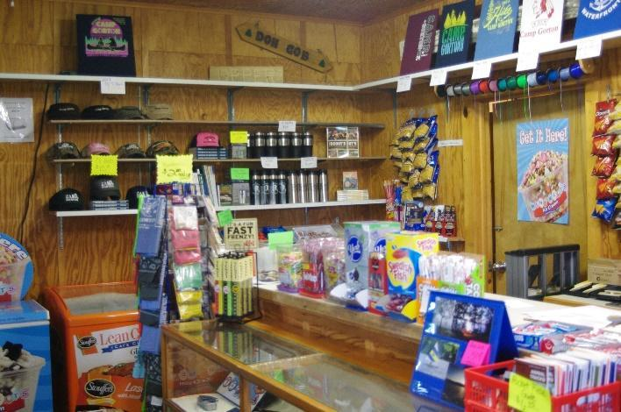
THE TRADING POST
Hundreds of merchandise selections

Snacks and Drinks for all tastes

Camp Gorton merchandise for every season

National BSA Supply selection

Uniform parts, patches, and insignia

Pocketknives and essential Scouting gear.
Cash, Check and Debit cards accepted.

”Large camp selection, outstanding customer service”

Mail Service

Outgoing mail should be deposited at the mailbox located in the camp office, and leaves camp at 10:00 AM each morning. Incoming mail will be distributed in the campsite mailboxes located in Headquarters.
Mail at Camp
Camp Gorton
Scout’s Name
Unit Number/Campsite
4241 County Route 25
Dundee, NY 14837

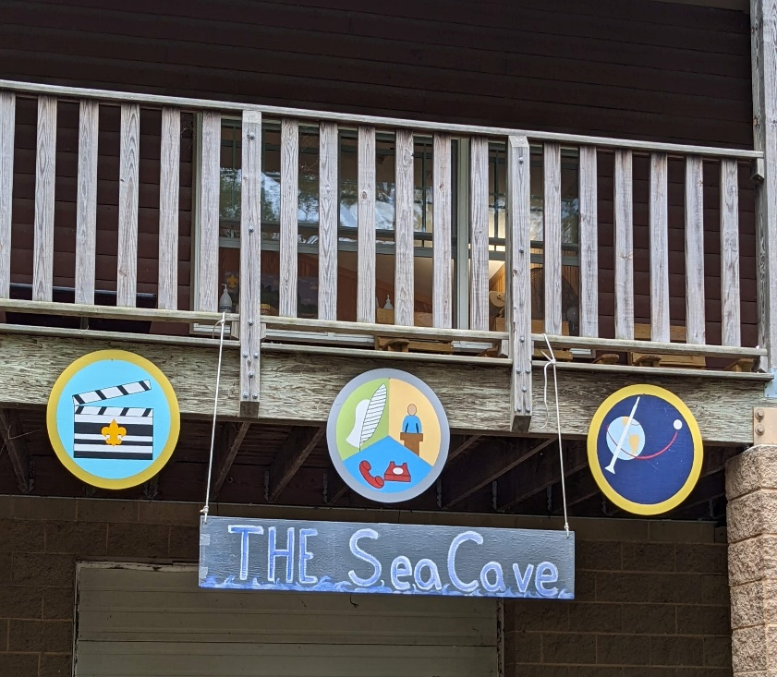
Camp Program
While every bit of information in this leader’s guide is important, this is where the magic happens. Camp Gorton prides itself on the top-notch program that we deliver to each and every Scout, parent, and adult leader. Our staff truly believes that we are America’s Finest Scout Camp and that is reflected in our program. This leader’s guide is simply an introduction to the phenomenal program we offer. Our Program Guide will be released in early February 2023.

Check the Five Rivers Council website and all of our social media sites to stay updated with the newest additions and developments to our 2023 program.

Things to Keep in Mind

- The camp program is limited only by a unit’s participation
- Planning before arrival helps a unit get the most of their experience
- The staff can only help when we know what you need. Please ask about extra programming. We are always willing to do whatever possible to help you meet the needs of your Troop, patrols, and individual Scouts.
- Summer camp is a great place for Scouts to fully lead their program. Encourage your SPL and Patrol Leaders to take charge of program planning.

Open Area

There will be designated times each day for Scouts to move freely through camp. Scouts can use this time to visit their favorite program area, work on extra merit badges, develop skills, and work on various camp awards. Scouts must have a buddy as they move through camp.

Morning and Evening Colors

Scouts are encouraged to participate in our flag ceremonies each day. Interested Scouts should talk to a staff member prior to the ceremony in which they would like to help. Morning Colors will occur at 7:45 AM and Evening Colors will occur at 5:45 PM. Field Uniforms are expected for evening colors.

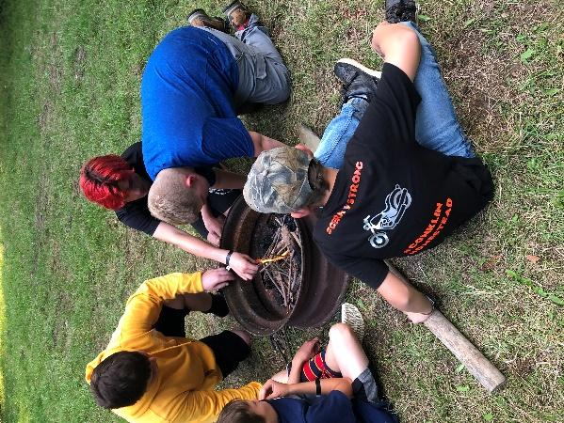
Hilltop Outpost

Camp Gorton has a beautiful outpost area at the top our hill on the far side of the road. Scouts in our First Year Resident Experience program, Camping Merit Badge, and Wilderness Survival Merit Badge will leave at 4:00 PM on Thursday to cook dinner and spend the night on the hill. A suggested packing list for this outpost can be found at the end of the Leaders Guide.

Order of the Arrow Day

Wednesday is Order of the Arrow Day at camp. We will have a recognition of members who have been elected or who have completed their Ordeal. There will also be special programing for the day and an opportunity for lodge members to seal their membership in the Brotherhood. All OA members are asked to wear their OA sash to evening colors and dinner.

Merit Badges
Scouts will have many opportunities to earn merit badges throughout the week. There are four hours each day dedicated to merit badge instruction and different areas may be able to accommodate extra merit badge work during open areas.

Many badges are well suited for first or second year campers who are still new to the Scouting program. Other badges tailor themselves to older Scouts who may have many Eagle required badges and are looking for a challenge. Please follow these suggestions as much as possible to ensure that all Scouts are in badges that match their ability level. This will be released after the BSA releases the 2023 Scouts BSA Requirements Book.

Some badges may have requirements that simply cannot be done at camp and that’s ok! These requirements can be completed prior to arriving at camp and given to the pertinent merit badge instructor or they can be completed after the Scout returns home.

Camp Gorton uses Black Pug Event Software to track advancements earned during camp. Through this system, units can access all advancement records at any time, upload advancement into Scoutbook and print blue cards.

Pre-Registration, Waitlists, and Conflicts

Your unit will be sent information regarding online merit badge signups in April. Please ensure all Scouts select a first and second choice for each merit badge instruction period. Some badges have class limits due to space, time or equipment restrictions. Waitlists will be generated for each of these classes, but Scouts should be prepared with other class choices should too many Scouts sign up for a specific badge. Class spaces for these classes are filled on a first-come, first-served basis.

When you arrive at camp, you will be given a list of your Scouts and the badges they are signed up for. If there are any issues or conflicts, or if any of your Scouts would like to change any of their badges, there will be a merit badge roundtable in the Dining Hall, with area directors immediately following dinner on Sunday night.

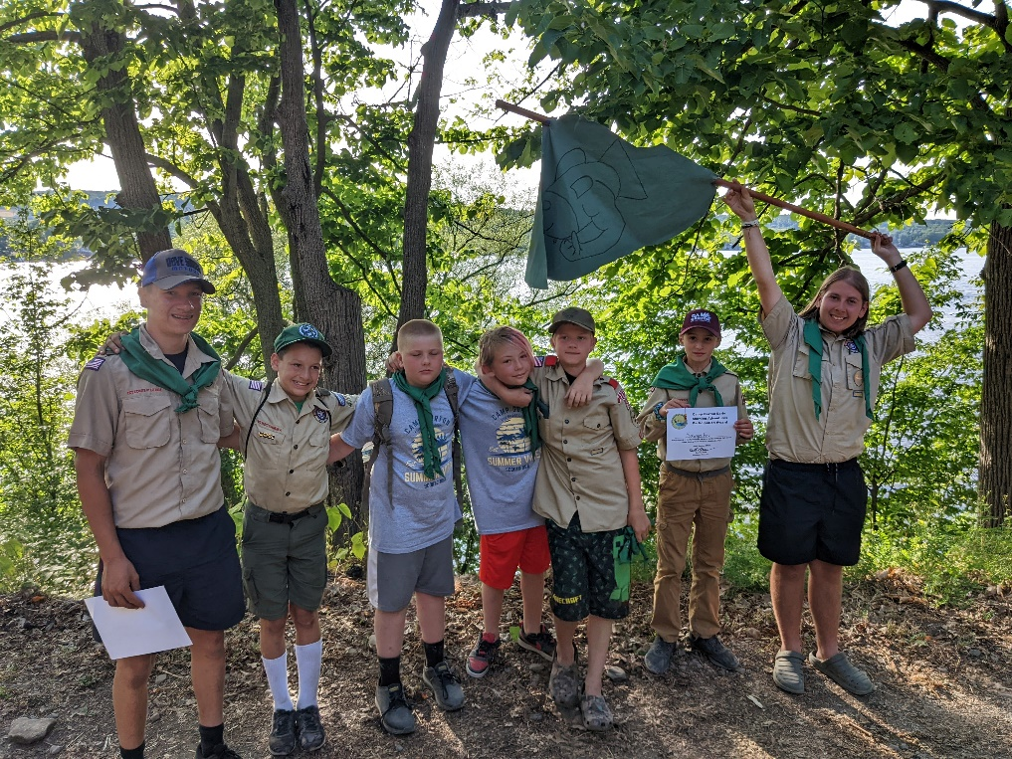
Gorton Honor Patrol

The Gorton Honor Patrol Award, redesigned for 2023, promotes and strengthens the patrol method in camp. An Honor Patrol is an exemplary group of Scouts who are committed to the patrol method, understand its benefits, and apply it in their daily lives. This program is designed to allow patrol members to explore all aspects of Camp Gorton.

Those patrols that complete the Honor Patrol program in their week at camp will receive a banner for their Troop flag and each member of the patrol will receive a Gorton Honor Patrol neckerchief.

Adult Leader Trainings

Many different adult leader trainings will be made available over the course of your stay at Camp Gorton. Past courses have included Safe Swim Defense, Merit Badge Counselor Training, Introduction to Outdoor Leader Skills, and many others.

As the summer approaches, the trainings we will be able to offer will be announced through the council website and social media sites. If you or any leaders in your unit have any trainings that you would like to see offered while you are at camp, please email the Camp Director or Program Director.

GET READY FOR GREAT CAMP EXPERIENCE!!!

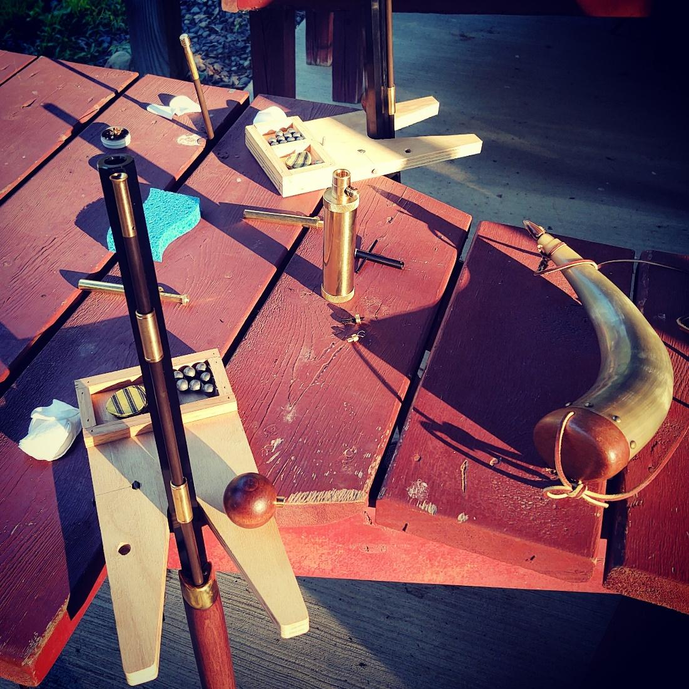
CAMP FORMS
AND CHECKLISTS

Five Rivers Council Summer Camp
SCOUT EARLY RELEASE FORM

This form is used in the event a Scout will need to leave camp, for any reason, prior to the scheduled end of their session. This should be completed prior to expected pickup date and turned in by your Unit Leader to the Camp Director at Check in.

The below named Scout is authorized to depart camp earlier than scheduled by their Pack or Troop.
Additionally, the below named individual is the person authorized to pick up my Scout.

Date and Time of Release: _______________________________________________________

Name of Scout: _______________________________________________________________________________

Mailing Address: _____________________________________________________________________________

City/State/Zip: _______________________________________________________________________________

Home Telephone No: ________________________ Troop: _________ Council: ______________________

Authorized Release to - Individuals Name: ________________________________________________________

Mailing Address: _____________________________________________________________________________

City/State/Zip: _______________________________________________________________________________

Home Telephone No: _________________________ Work Telephone No: ________________________

Parent’s (Or Legal Guardian’s) Printed Name: ____________________________________________________

Parent’s (Or Legal Guardian’s) Signature: _______________________________________________________

Parent’s (Or Legal Guardian’s) Work or Cell Phone: _______________________________________________

Comments: __________________________________________________________________________________

____________________________________________________________________________________________

************************************* On Site Verification *************************************

Before leaving Camp, Scouts must check-out with their unit leader and the camp office.
Signature of Unit Leader Date
Unit#
Signature of Camp Director Date
(Keep original for use at time of release. Give authorized individual a photocopy if requested.)

Individual Equipment Checklist

***Be Prepared. Camp is a 7-day experience, and each Scout and adult leader should pack accordingly. ***
Bedding

- Pillow
- Sheets and Blankets or a
- Sleeping Bag
Optional Items

Fishing Gear
Alarm Clock
Camera
Compass
Religious Literature
Musical Instrument
Notebook
Writing Utensils
Mosquito Netting
Clothesline
Hangers (Must be Plastic)
FYRE/ Camping MB Scouts
In addition to regular gear, Scouts will need these items for the Hilltop Experience

- Extra Camping Backpack
- Mess Kit
- Ground Pad
- Tent@
- Sleeping Bag

@ We encourage Scouts to bring one of their troop’s tents that they are familiar with.
Items to Leave at Home

Candles, Radios, Valuable Items, Fireworks,
Aerosol Cans, Guns, Ammunition, Bows,
Military Clothing, Bicycles, Pets, Open-toed Shoes, Lighters, Sheath Knives

Electronic Devices

We ask that Scouts use electronics at appropriate times when at camp. While Camp Gorton does not discourage their use, please ensure that you are fully participating in the program!
Clothing

- Complete Scout Uniform
- Field Uniform
- Activity Uniform
- Scout Shorts
- Scout Socks
- Scout Belt
- OA Sash (if applicable)
- Scout appropriate T-Shirts
- Shorts
- Long Pants
- Extra Socks and Underwear
- Shoes (extra pair suggested)
- Raincoat/Poncho
- Hat
- Sweatshirt/Jacket
- Swim trunks or one-piece swimsuit
- Water Shoes*
*Closed Toe Water Shoes are required in Waneta Lake per NYS Health Department Policies.
Personal Items

- Completed BSA Medical Form – Parts A, B and C
- Footlocker or plastic tote
- Flashlight
- Extra Batteries
- Water Bottle
- Sunscreen
- Non-aerosol Insect Repellent
- Toiletries
  - Shampoo
  - Soap
  - Towel/Washcloth
  - Toothbrush
  - Toothpaste
  - Comb/Brush
- Medication in original container
- Merit Badge Prerequisites
- Pocketknife
- Spending Money
Camp Checklist

Pre-Camp
- Pay reservation deposit of $100 to reserve a camp session
- Distribute Campership Application Forms to families
- Distribute BSA Health Forms
- Inform families that you will be attending camp from _______ - _______
- Encourage parents to sign the Photo Release on the health form
- Arrange for two adult leaders to be in camp at all times
- Arrange for adequate transportation of Scouts, adults, and gear to and from camp
- Pay camp registration fees.
- Early Bird Fee Deadline: 5/1/2023
- Collect completed BSA Health Forms and make second copies to be submitted to camp
- Collect any completed and signed Early Release Forms
- Complete Scout & Adult Roster
- Have copies of all camp related receipts and forms organized for arrival at camp
- Send the Camp Director a list of all adult leaders and birthdates to: campgortondirector@gmail.com
- AT LEAST TWO WEEKS BEFORE ARRIVAL
Check-In
- Arrive at camp as a unit to begin check-in between 1:00 PM and 2:00 PM
- The camp staff is not in a position to handle early arrivals
- Check-in with Camp Commissioner and meet your Site Guide
- Check-in at the camp office and Be Prepared with the following items:
- Final Scout and Leader counts
- 4 Updated copies of Scout & Adult Roster
- Follow your Site Guide to your campsite to drop off Troop materials and personal gear
- Complete site check-in inspection form before anyone moves into tents
- Have ALL Scouts and leaders change into their swimsuits
- Go to the Health Lodge for medical review
- Have your med forms and prescription medications ready
- Report to the Dining Hall for table assignments and orientation
- Report to Waterfront and have ALL Scouts and leaders take the swim test
- Send one leader to the 4:00 PM Leader’s Meeting in Memorial Lodge
- Conduct a 4:00 PM Troop Meeting with your site guide

Before You Leave
  - Check unit advancement records
  - Resolve issues with the appropriate area director
  - Pack all Troop gear and be prepared to leave Saturday morning
  - Attend the Closing Ceremony
  - Meet your Site Guide and check your unit out of your site
  - Clean latrines, picnic tables, and police for trash in your site
  - Return all camp tools and items to the Quartermaster
  - Submit unit evaluations to the Trading Post and pick up your unit patches and leader gifts
  - Check out at Health Office and pick up all Health Forms and return medication boxes
  - Reserve your Unit’s 2024 campsite online or in headquarters

